Using an AWR Report to Size an Azure VM

Authors: Kellyn Gorman and Tim Gorman

# Scope

This document uses the Automatic Workload Repository, (AWR) to gather workload data for an Oracle database and provide estimates for sizing once specific fields from the report are populated to an Excel spreadsheet.

***Disclaimer:*** *Each version and database type of the AWR report can display data differently. The fields are the same, but the data may be in a different order, have a different header, etc. This document is to offer guidance in filling it out. If unsure, escalate for assistance, as an incorrect number could impact sizing estimates immensely.*

# Assumptions

* AWR Report with 7-day or longer workload report
* The AWR Analysis sizing template
* Basic understanding of AWR data and Excel
* The Oracle database is either a single Oracle instance or RAC
* The Oracle database isn’t on an engineered system such as Exadata

# Process

Although the AWR report can provide essential data about workload, database usage and optimization for a cloud project, specific calculations can offer us invaluable data on what is required for an Azure IaaS VM to run the Oracle database in the cloud. The following will explain step by step what values to gather from the report and where to place them in the spreadsheet.

The Spreadsheet is broken down into two worksheets, the AWR and the Calculations worksheet. There are multiple lines to take RAC and multiple instances into consideration.

# The AWR Worksheet

The first three columns:

**DB Name:** the unique name given to the database.

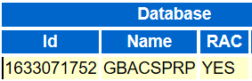

**Instance Name:** Is the same as individual database node names in RAC or often the same as the DB Name for non-RAC databases.

**Host Name:** The name of the host. For RAC, each node will have a unique name.

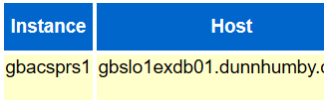

**Elapsed Time and DB Time:** These two sections are commonly next to each other throughout the report.

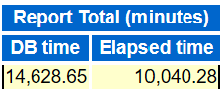

**DB CPUs**: This can be a confusing metric, as CPU data is in numerous fields, but the value we’re searching for is referred to as “DB CPU(s)”. Enter it for each instance involved in the estimate.

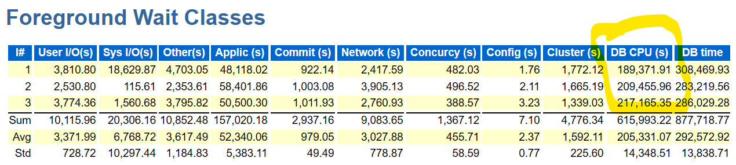

**CPUs/Cores**: Hyper-threading makes it important to have both these numbers. We commonly calculate off of the Cores value and ensure that you update the CPU calculation for it in the spreadsheet if you do note that there is hyperthreading involved. For the example below, a 3-node RAC has 320 hyperthreaded CPUs, with 160 CPU cores total for each.

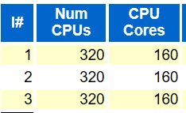

**Memory(GB):** Memory is captured in the same line as CPU information, but it is calculated differently than we need in our spreadsheet. Remember to convert from MB to GB as part the steps when you enter the info.

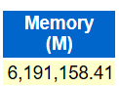 / 1024= Correct Value for Spreadsheet

**%Busy CPU:** This value is clearly stated in the report and is used to identify CPU saturation. A CPU is either on or off, but to know if enough CPU is available is part of our estimates. This is another value that can be confusing to gather. Go to the OS Statistics and for each instance CPU totals, look for %Busy.

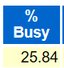

**SGA(MB):** This can be under different tables, depending on the version. It can be a good idea to do a search for “SGA”. SGA Target demonstrates the beginning and end values for an adjusting vale. If you use this section, take the highest of the two values, (peak). If no value is shown for an ending value, it means no adjustment was made from the beginning value.

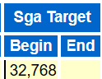

**PGA(MB):** Is the Process Global Area and this is a specialized area of memory allocated for sorting, hashing and other important processing. Heavier sorting is performed in Oracle due to lacking clustered indexes in the Oracle design. The memory allocated may not meet the needs of the database, which is a resiliency vs. sizing issue. Like SGA, the PGA Target will display a beginning and ending value for some AWR Reports. Take the larger of the two values displayed.

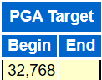

**Read Throughput(MB/s) and Write Throughput(MB/s):** This is a value that can be displayed in multiple ways and sections in the AWR report depending on the version and type of Oracle product. Search the report, (find on page if in a browser) for “IO Statistics”. For the example below, a RAC database with 3 nodes, displays the Read throughput and write throughput for each instance:

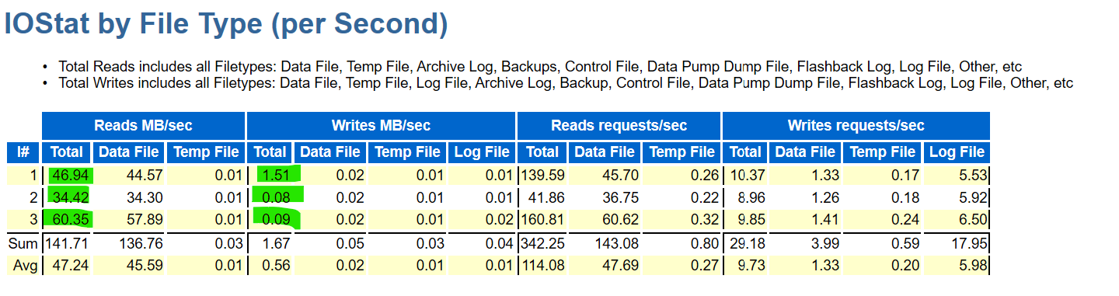

**Read IOPs/Write IOPs**: Like throughput, this section can be displayed in different parts of the AWR report, but often is in the Load Profile towards the top of the report or in the IO Statistics in the mid-section of others.

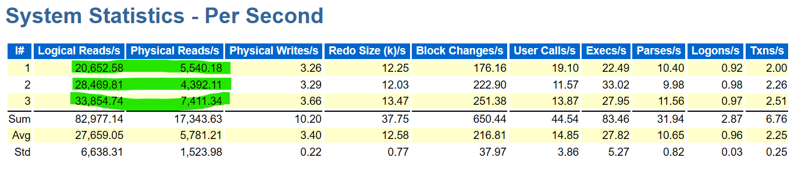

# Calculating Factors for Worksheets

Once you’ve filled in this information, note that there is a gray box below the area to enter in all sections for instances:

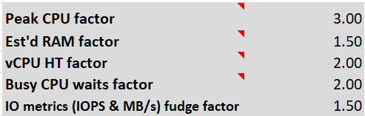

These values are here to help calculate for the type of workload that you are brining over. For Exadata, an IO metric fudge factor would be high, (in the example, 6 times what is being experienced in the workload) to take increased IO into consideration from loss in offloading and other engineered features.

Decide what you want for each of the following and make changes based on the following:

**Peak CPU Factor:** 2.00 is standard, 4.00 is for a workload that might have a huge variance expectation once it goes to the cloud.

**Est’d RAM Factor**: Same for CPU, but for RAM estimate. Normal is 2.00, 4.00 would be normal for an Exadata where the SGA is commonly shrunk to promote offloading.

**vCPU HT Factor**: Commonly 2.00 and this should be the default going to IaaS Azure VMs

**Busy CPU waits factor:** 2.00 is the default

**IO metrics(IOPS & MB/s) fudge factor:** 2.00 is for transactional system, 4.00 is for DSS/OLAP, 6.00 is for Exadata.

# Calculations Spreadsheet

*Don’t fill in any area OUTSIDE of the fields instructed, which have headers* ***filled with******blue.*** *Columns are dependent on what is filled in on the AWR page to match what is in the appropriate fields on the Calculations page.*

1. Enter the DBName and Instance Name, duplicating the DB name if necessary, that corresponds to the instance name. Do not leave the first column blank if you filled in the second.

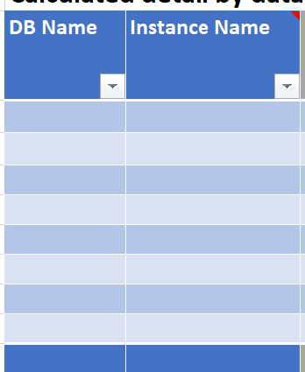

1. Although the column looks like it extends for two, place the hostname for the servers for every instance in the first column of the next section.

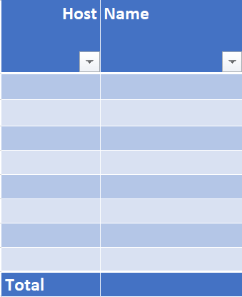

1. Enter the db name, (database name, NOT instance name) in the third section, first column. If working on a RAC environment, the RAC database will be listed by the DB name one time, not for each node in this section. The Excel spreadsheet will calculate and total the resources required for a **single instance,** as this is our primary goal to achieve a fully supported environment on Azure by Oracle.

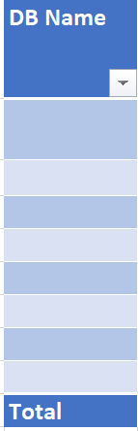

As you’re entering the values into this second worksheet, calculations will appear. Once complete, you should have values for each database to size the workload into Azure. These values will then give you the information you need to choose one or more IaaS Azure VMs to size out a solution for the Oracle customer.

# Example of Calculations for RAC to Single Instance

The following is an example of the output from a customer engagement. This involves two databases, both 2-node RAC environments. Notice that the DB Name column is listed twice for both, then the instance name is unique. No other information was filled in, as the values in the previous worksheet automatically populates and calculates what is needed.

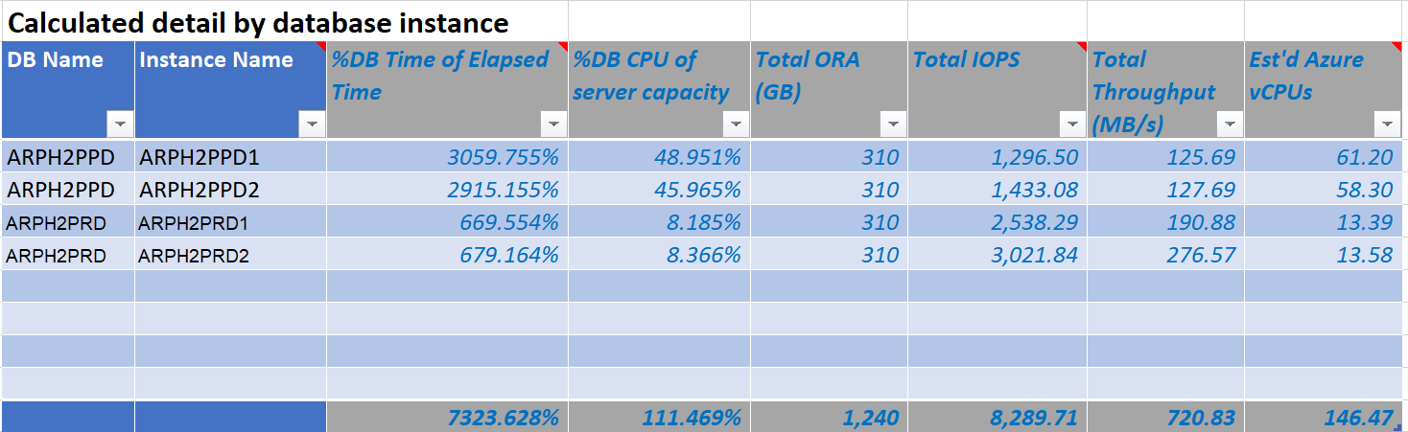

In the second section, only the host name was populated to the first column for each of the nodes for the RAC instances. As there are two nodes each for the two databases, four entries are added and the values populate from the first worksheet.

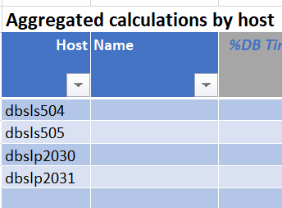

In the last section, I only listed the two, global database names. The data for each of the nodes for each of the databases is calculated and total resources are displayed for the environment to be moved to Azure IaaS VMs. With the factoring numbers taken into consideration, we have average workloads from the AWR and then peak workloads which are calculated from the workloads and the factoring numbers.

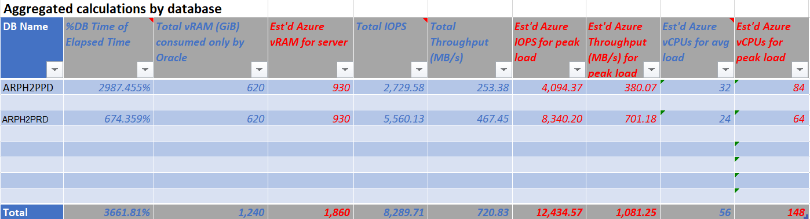

For our examples:

**ARPH2PPD** will require:

* 32 vCPU for an average load and 84 vCPU for a max workload.
* A server with 930G of memory and 620G allocated to the database.
* Disk IOPS 4094 and 380MB/s throughput

Calculations can be seen for the second database to be migrated to a single instance, ARPH2PRD.

There is a total that is displayed at the bottom, but this is only available if you need to know how many resources will be required towards the project. The values we have here is what we require to size out the Azure VM.